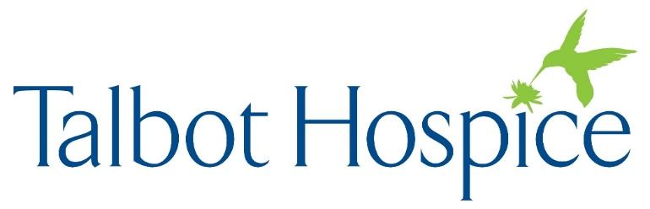
News Release
July 19, 2024
Contact: Wes Williams
410-822-2724, ext. 115

Talbot Hospice Receives 2024 Hospice CAHPS Honors Award

EASTON, MD—Talbot Hospice has been named a 2024 Hospice CAHPS (Consumer Assessment of Healthcare Providers and Systems) Honors Award recipient by HEALTHCAREfirst, a leading provider of CAHPS and bereavement survey programs for home health and hospice agencies. This prestigious annual review recognizes agencies that continuously go above and beyond in providing high-quality care for patients and compassionate caregiver experiences. It acknowledges the highest performing agencies by analyzing the performance of the Hospice CAHPS survey satisfaction and quality, as measured from the caregiver’s point of view.

“It is such an honor to receive this recognition," said Executive Director Molly Kirsch. “The award is based on feedback from our families and is a reflection of the compassionate care and services provided by Talbot Hospice staff and volunteers.”

Under the CAHPS program, the Agency for Healthcare Research and Quality AHRQ funds, under the US Department of Health and Human Services, oversees and works closely with a consortium of research organizations to conduct research on patient experience and develop surveys that ask consumers and patients to report on and evaluate their experiences with health plans, providers, and healthcare facilities. The CAHPS program also investigates and shares strategies for improving the reliability and validity of survey results, reporting survey results to interested audiences, and using the results to improve patients' experiences with care.



About Talbot Hospice
Talbot Hospice provides compassionate care, comfort and support for patients and their families and caregivers wherever they call home. Talbot Hospice serves patients facing life-limiting illnesses through hospice and palliative care services as well as grief support programs. Services are available to patients and caregivers regardless of ability to pay. Learn more at www.talbothospice.org.

###

